Searching for Orthologs

Orthologs are genes in different species that evolved from a common ancestral gene by speciation. Normally, orthologs retain the same function in the course of evolution.

1. Search for the gene adding “sgd” to the front of the name then select the link that represents a genome summary

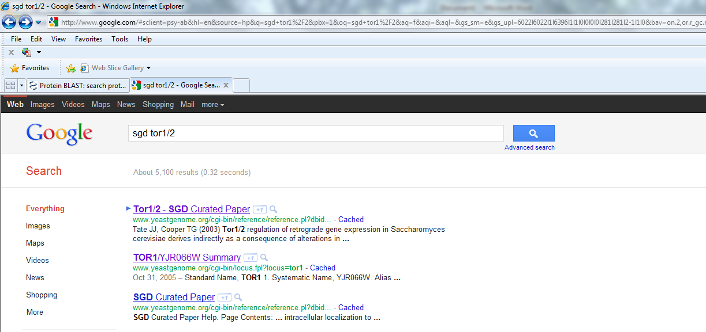

1. Ensure the drop down menu of Protein Info and Structures located under the right sidebar says Protein Info and click view

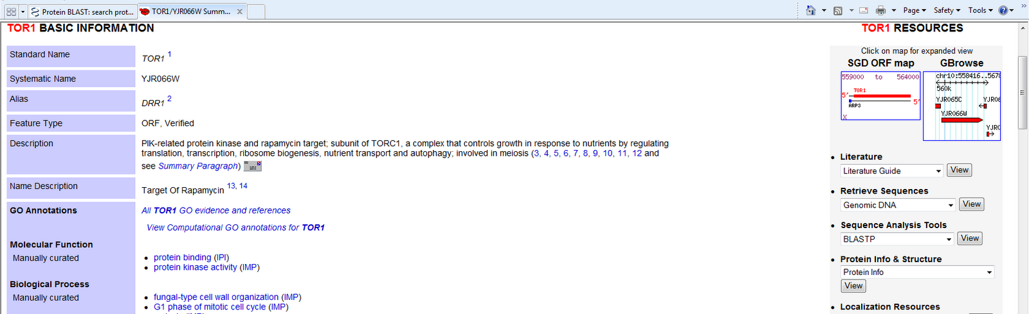

1. Scroll down until you see the amino acid sequence and click download:

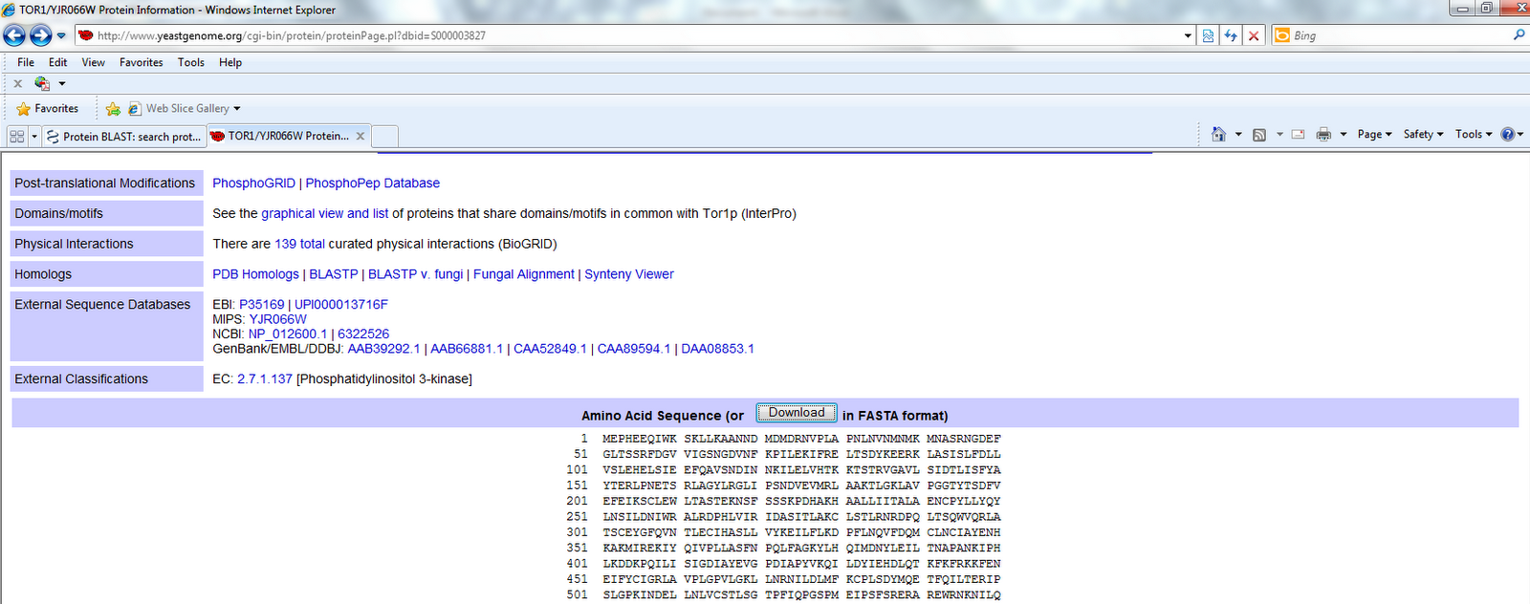

The next screen you see will look like the one below:

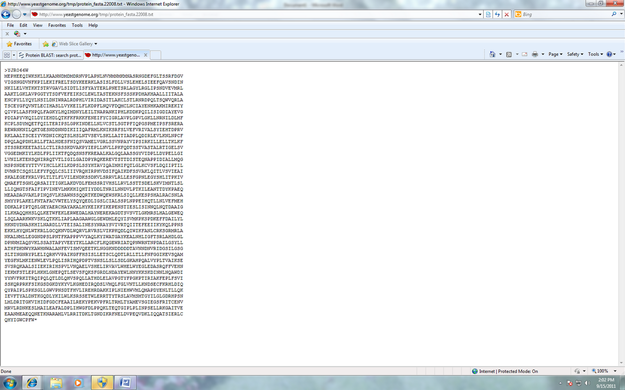

1. Open another tab in the internet browser and enter the following link:

<http://blast.ncbi.nlm.nih.gov/Blast.cgi?PAGE=Proteins>

1. Copy and paste the downloaded amino acid sequence you downloaded into the box in the new Blast tab. Under organism enter the organism you are studying. Be sure to click show results in a new window BEFORE you hit BLAST:

Paste amino acid sequence here

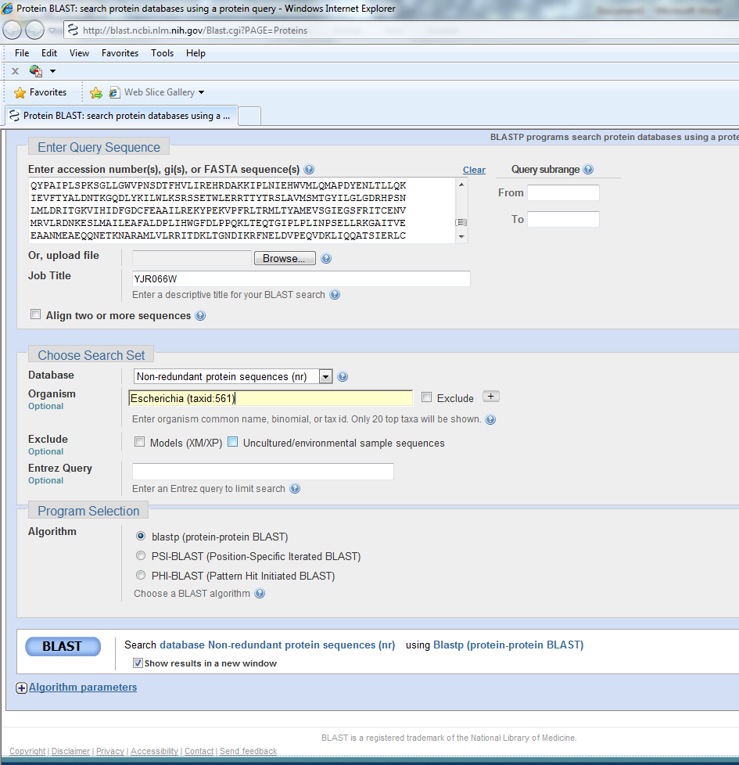

1. Wait while your results are gathered:

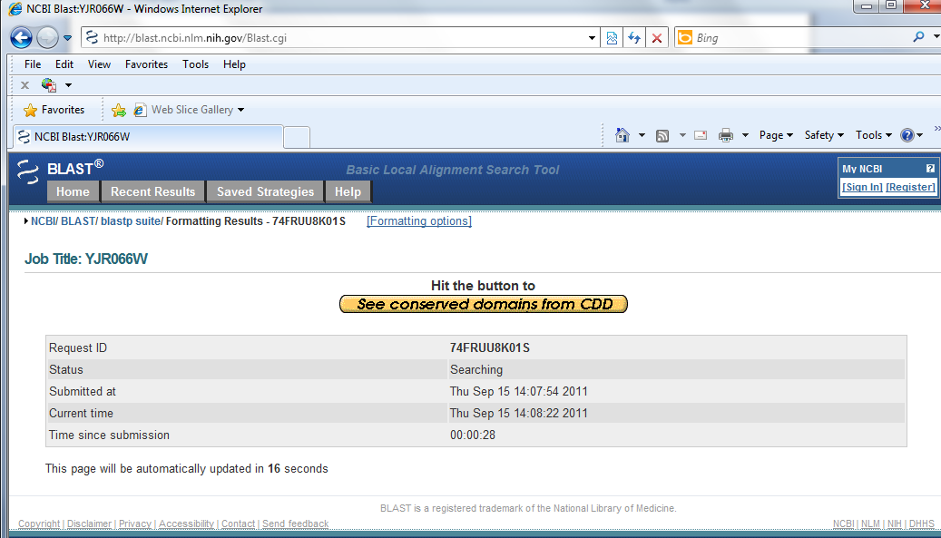

1. The results you gather should look like the snap shot below. Analyze the results and you are complete!

